**Bitcoin Stock-To-Flow Model**

The stock-to-flow model (SF), popularized by a pseudonymous Dutch institutional investor who operates under the Twitter account “PlanB,” has been widely praised and is the leading valuation model for bitcoin proponents. SF has achieved viral popularity and inspired rags-to-riches dreams for those gambling it all on the future of bitcoin. However, we believe the model’s accuracy will likely be about as successful at forecasting bitcoin’s future price as the astrological models of the past were at predicting financial outcomes.

Low rate of supply, which PlanB defines as “scarcity,” can be quantified using a metric called Stock-to-Flow (SF), which is the ratio between current supply and new supply.

This premise is then translated into the hypothesis, “…that scarcity, as measured by SF, directly drives value.” PlanB then plots bitcoin’s SF against USD market capitalization as well as two arbitrarily chosen SF data points for gold and silver.

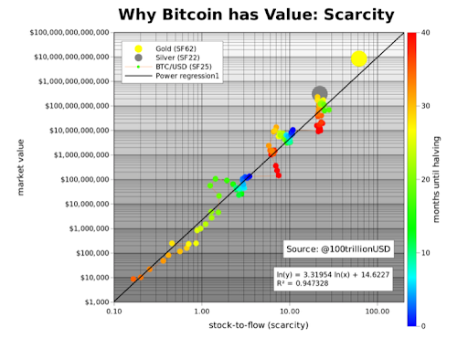

Figure 1. Taken from "Modeling Bitcoin Value with Scarcity," by PlanB.

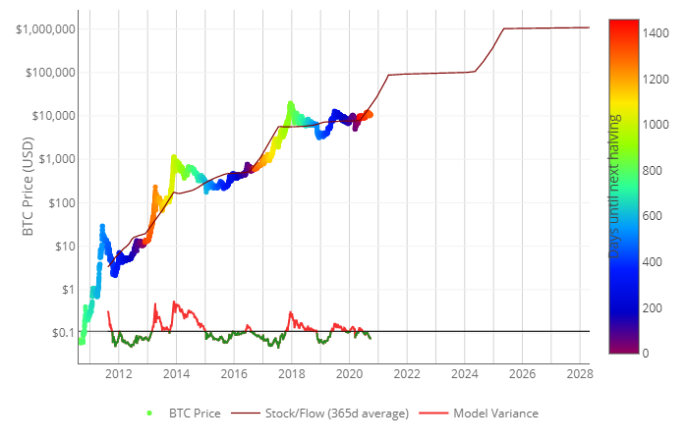 Figure 2. The chart Bitcoin prices over the years with respect to the S2F model

This model treats Bitcoin as being comparable to commodities such as gold, silver or platinum. These are known as 'store of value' commodities because they retain value over long time frames due to their relative scarcity. It is difficult to significantly increase their supply i.e. the process of searching for gold and then mining it is expensive and takes time. Bitcoin is similar because it is also scarce. In fact, it is the first-ever scarce digital object to exist. There are a limited number of coins in existence and it will take a lot of electricity and computing effort to mine the 3 million outstanding coins still to be mined, therefore the supply rate is consistently low.

Stock-to-flow ratios are used to evaluate the current stock of a commodity (total amount currently available) against the flow of new production (amount mined that specific year).

Why the model is a bad idea for bitcoin

It is a model that was drafted based on assumptions and inference of the model utilized on gold, silver other tangible assets. The model is not considering a lot of factors like;

1. The effect of technology on the digital currency.

The way

1. Emergence of new and stronger coins
2. International policies
3. Anonymity of traders

These along with other reasons make the S2F model a bad idea for bitcoin.

An example of why the model is a bad idea for bitcoin, every four years the bitcoin has been designed to go through halving (a process by which the quantity of bitcoin in circulation is reduced by half). According the S2F model, in 2019 it predicted that after the next halving (designated to take place this year in May 2020) the market cap of Bitcoin worldwide was going to increase largely from up-to $1,000,000,000,000 (One trillion dollars). As at 27th of September 2020, the total market cap of bitcoin totals at $198,769,963,009 (approximately $200 billion) barely a 20% of the predicted value.